# Lab 10 – Plotting in MATLAB

## Lab warm-up assessment

Group of 03 students for activity

Take about 15 minutes to complete the following assignment. The first time you need help, ask you to neighbor students for their recommendation. The second time you need help, call the instructor over for assistance.

1. shows how to plot more than one line by passing multiple x,y pairs to the plot function. Define y1 and y2 as sine waves with a phase shift.

**Output:**

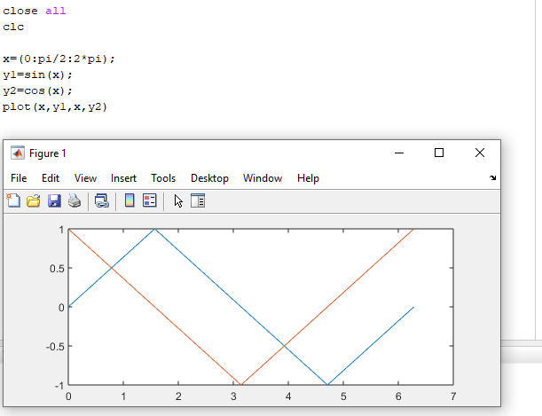

1. shows how to plot two sine waves with different line styles by adding a line specification string to each x,y pair. Plot the first sine wave with a dashed line using '--'. Plot the second sine wave with a dotted line using ':'. (hint : plot(x,y1,'--',x,y2,':'))

**Output:**

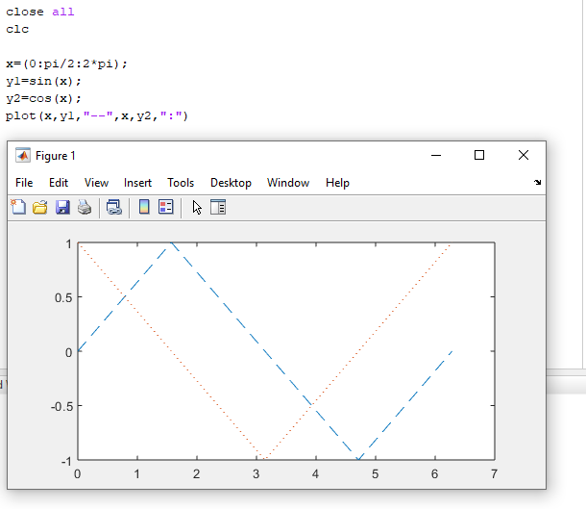

1. shows how to specify the line styles and line colors for a plot. Plot a sine wave with a green dashed line using '--g'. Plot a second sine wave with a red dotted line using ':r'. The elements of the line specification strings can appear in any order.

**Output:**

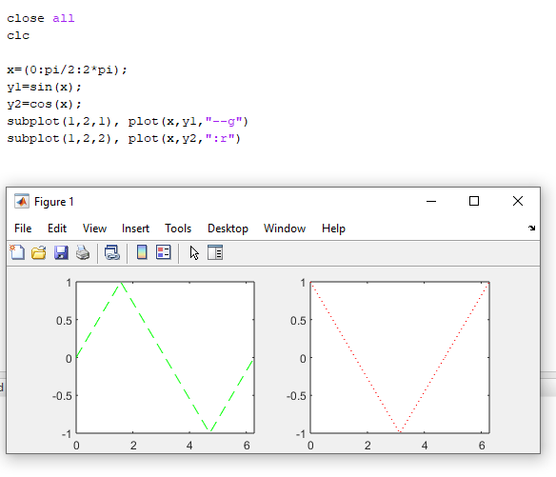

## Exercise

### Exercise 1

Create an m-file as follows (note that MATLAB uses angles measured in radians):

% sine_wave_plot.m

% Created by “YOUR NAME” on “TODAY’S DATE” clear

x=[0:0.01:4*pi];

y=sin(x);

plot(x,y)

title('Plot of a Sine Wave')

ylabel('y values')

xlabel('x values')

grid on

figure(gcf)

**Be sure that the screen shows all three parts:**

1. The Script (.m) file.
2. The Command Window, showing that you ran the Script file.
3. The Plot Window, showing the plot.

**Output:**

